DTG will close public access to 80 acres and most Rocky Top trails
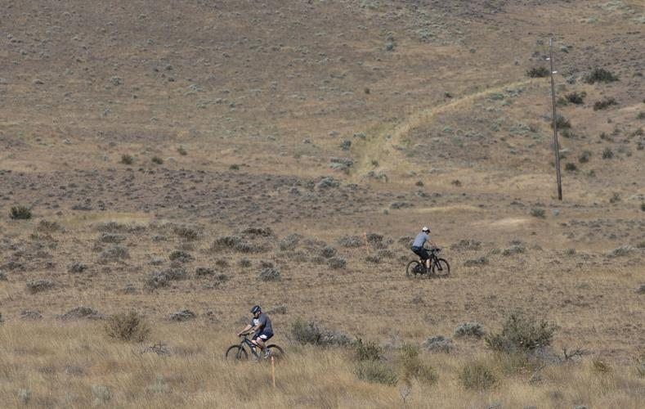
By LUKE THOMPSON Yakima Herald-Republic, February 2, 2023
People ride bikes on trails at Rocky Top Saturday, Aug. 13, 2022, in Yakima, Wash.
Evan Abell / Yakima Herald-Republic

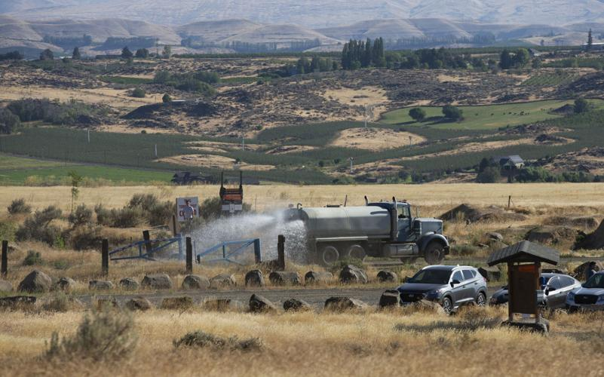

A truck puts water on the road to the landfill at Rocky Top Saturday, Aug. 13, 2022, in Yakima, Wash.
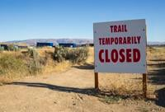
Evan Abell / Yakima Herald-Republic

The Gus's Gully trail at Rocky Top is pictured closed Saturday, Aug. 13, 2022, in Yakima, Wash.
- Evan Abell / Yakima Herald-Republic

DTG Recycle will shut down public access to 80 acres of the land it owns at Rocky Top, effectively closing off most of a popular Yakima trail system.
DTG operates a recycling center and limited-purpose landfill for construction waste at Rocky Top. The previous owner of the rock and demolition pit allowed hikers, mountain bikers and horseback riders to use the land for recreation.
Cowiche Canyon Conservancy will maintain its easement for access to the Rocky Top trailhead, and CCC Executive Director Celisa Hopkins said the "Walk N Roll" trail will still be accessible. The parking lot by the trailhead will remain open.
A news release from DTG noted it plans to work with the William O. Douglas Trail Foundation "to maintain safe access to this historic trail" around the landfill.

Concerns about expansion
DTG continued to allow public access when it acquired the property in late 2019, but a news release from the company Wednesday blamed "neighbor complaints" for the change of plans. The company said at the time recreation was allowed, it was believed that area would "not be active for decades," and DTG intended to follow the original development plans.
As DTG expanded its operations, the neighborhood group Friends of Rocky Top, along with consultant Scott Cave, raised concerns about trash, air quality and potential groundwater contamination at the site, which in turn drew attention from regulatory agencies.
"Stop being out of compliance and we can stop complaining," Cave said. "People don't want to spend their days having to track the operations of this facility."
The Yakima Health District, Washington Department of Ecology and the Yakima Clean Air Agency responded by halting DTG's expansion and giving DTG a list of requirements to ensure compliance.
So far DTG's taken some steps, such as adding a monitoring well, hiring a landfill manager and picking up trash on the trails managed by the Single Track Alliance of Yakima, a nonprofit group dedicated to maintaining trails for all.
DTG initially planned to move into a new area to the west of its current operations where it had already started gravel mining and blasting. But regulatory requirements and the identification of a 1,000-foot setback from a neighbor's home that was previously unrecognized by DTG halted that progress. In its release, DTG said that forced the company to move its operations to the south, causing conflict with trails.
"Because DTG was already forced to prematurely move into the Southern Fill Area, development will continue moving south and west of the Southern Fill Area, making it unsafe for recreational users to be in an area under active development," the release said.
Nancy Lust of the Friends of Rocky Top said it would have been possible for DTG to abide by the setback and still move its development to the west, where trails wouldn't be affected. Instead, DTG said the complaints forced it to move waste into the south and led to continued development south and west of the current "Southern Fill Area."
"DTG doesn't like being accountable and sometimes they can overreact," Lust said. "I think this is their attempt to make it harder for concerned citizens and neighbors to be able to take pictures of what they're doing in their operation because we need those pictures when we file complaints."

Trail access
Single Track Alliance of Yakima Vice President Will Hollingbery said he hopes to work with the William O. Douglas Trail Foundation to establish new connections to the Rocky Top trails not located within the closure.
Hollingbery added he's heard of no plans to shut down the nearby dirt jumps, but the closure cuts off all connections to other trails within the system.
"From my perspective as the trail builder, I think the whole place is shut down until we make some connections for the lower trails," Hollingbery said of the trail system he started work on in 2011.
Both Hopkins and Hollingbery said DTG gave them no warning before announcing its permanent closure.
The trails have been temporarily closed due to mud since Jan. 9.
Reach Luke Thompson at luthompson@yakimaherald.com.

MORE INFORMATION
- Proposed expansion to Rocky Top landfill draws ire of neighbors, prompts environmental probes
- DTG's expansion looms over trails at Rocky Top west of Yakima
- Yakima County commission candidates asked about Rocky Top landfill issues during forum

Luke Thompson
I’m Luke Thompson, a reporter in my seventh year at the YH-R following stints at seven publications in the preceding seven years. My primary focus is covering the many great prep sports stories in the Yakima Valley, as well as the sports at Yakima Valley College and Central Washington University. I also cover Pippins baseball and Outdoors features. After spending my childhood in Kansas followed by college at the University of Missouri and jobs at various papers in the South/Midwest, I’ve tried to make up for all those years without mountains by spending a lot of time in the Cascades skiing, hiking, camping, or just exploring on my own or with my wife and our dog.
- Author email

